1. Write a query to find the addresses (location_id, street_address, city, state_province, country_name) of all the departments.    
   Hint : JOIN

select l.location_id,l.street_address,l.city,l.state_province,c.country_name

from locations as l

inner join countries as c

on l.country_id=c.country_id;

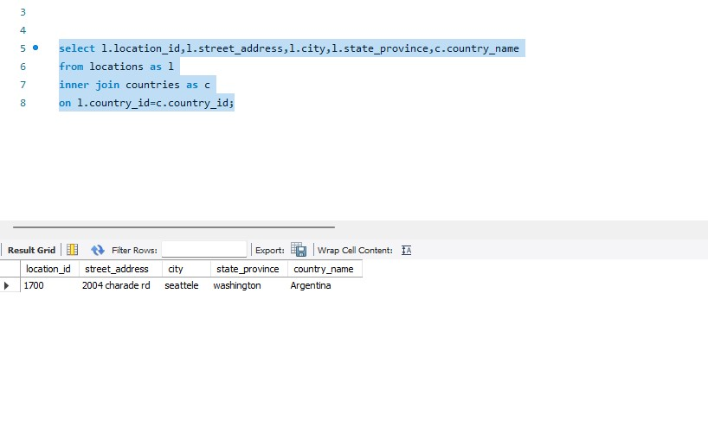

1. Write a query to find the name (first_name, last name), department ID and name of all the employees.

SELECT e.FIRST_NAME,e.LAST_NAME,d.DEPARTMENT_NAME

from employees as e

inner join departments as d

on e.DEPARTMENT_ID=d.DEPARTMENT_ID;

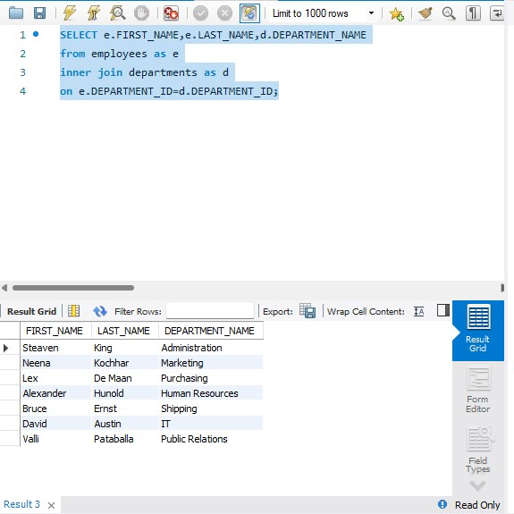

1. Write a query to find the name (first_name, last_name), department ID and name of the employees who works in Seattele.

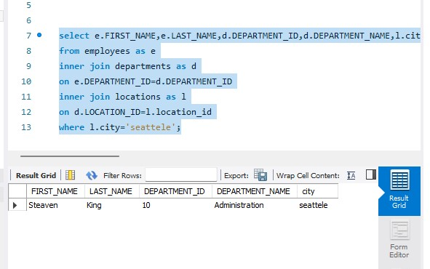

1. Write a query to find the name (first_name, last_name) and the salary of the employees who have a higher salary than the employee whose last_name='Hunold'.

select e.FIRST_NAME,e.LAST_NAME,e.SALARY

from employees as e

where salary > (select es.salary

from employees as es

where es.LAST_NAME = 'hunold');

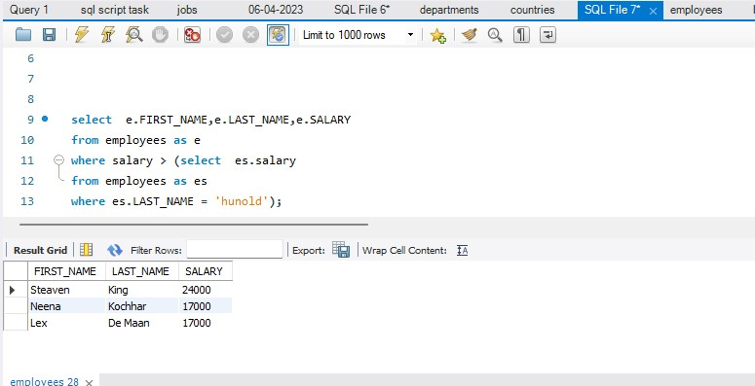

5. Write a query to find the name (first_name, last_name) of the employees who have a manager and worked in a US based department.

Hint : Write single-row and multiple-row subqueries

select e.FIRST_NAME,e.LAST_NAME,e.JOB_ROLE

from employees as e

where JOB_role = (select e.JOB_ROLE from employees as e

inner join locations as l

on e.LOCATION_ID=l.location_id

where country_id='US');

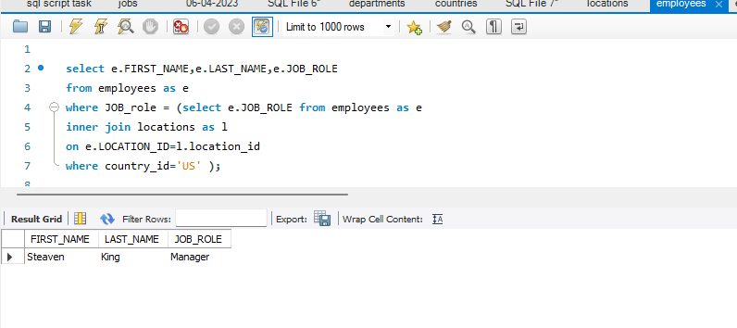

6.Write a query to find the name (first_name, last_name) of the employees who are managers.

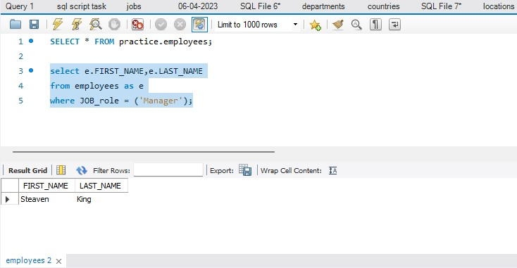 select e.FIRST_NAME,e.LAST_NAME,e.JOB_ROLE

from employees as e

where JOB_role =('Manager');